**ML System Design for Event Recommendation System**

Credit to the video: [https://www.youtube.com/watch?v=ULHk2WYM86M](https://www.youtube.com/watch?v=ULHk2WYM86M&list=PL_b_MRp1BnEj4UuHv1jAGeO1a0VTRXsAk&index=12)

**Problem Statement/ Business Objective/ Clarifying Requirements:**

* To build a personalized event recommendation system
* Perhaps for an Event Management and Ticketing platform to increase ticket sales.
* Something like Eventbrite or FB or LinkedIn.

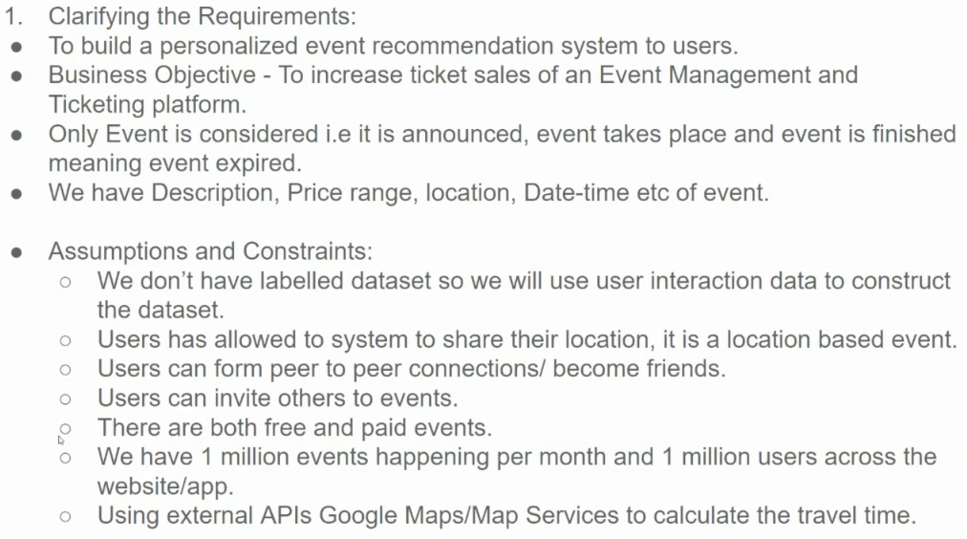

* Does it need to be personalized for the user? Personalized for the user
* User locations? Worldwide (multiple languages) – assumption for US only now.
* Latency requirements - 100msec?
* Data access
  + Do we log and have access to any data?
  + Can we build a dataset using user interactions?
  + Do we have textual description of events?
  + Can we use location data (e.g. 3rd party API)? (events are location based)
  + Can users become friends on the platform? Do we want to use friendships?
  + Can users invite friends?
  + Can users RSVP or just register?
  + Free or Paid? Both
* Is there an existing system already in place?
* What is the main objective: accuracy, latency?
* Is there labeled data? If so, how much
  + Can we trust the quality of data coming in?
* Where the model will be deployed? [cloud, edge, etc]
* Are there any constraints or limitations on model complexity or size?
* What are the key success metrics for this ML system in the long term?

**Key Considerations and Constraints:**

1. **Event Lifecycle: Events have three states: announced/ upcoming, ongoing, and finished. Recommendations should only be made for upcoming events.**
2. **Event Data:** Each event has attributes like description, price range, location, and date-time.
3. **User Data:** Users provide location information. Users can form social connections with other users. Users can invite friends to events.
4. **System Scale:** The system needs to provide recommendations probably real-time or the event recommendations can be calculated daily as a batch job.
5. External APIs (Google or something else) are used to calculate travel times.
6. What kind of interactions can a user do?
   * Private events: ticket purchase
   * Public events: RSVP – interested, going, not going, not interested

**Framing as ML Task**

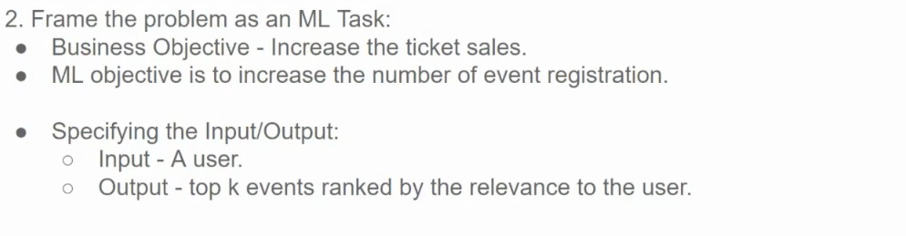

ML problem is to suggest events for the user that the user is most likely to attend. So, a candidate generation (using a recsys algorithm) followed by ranking.

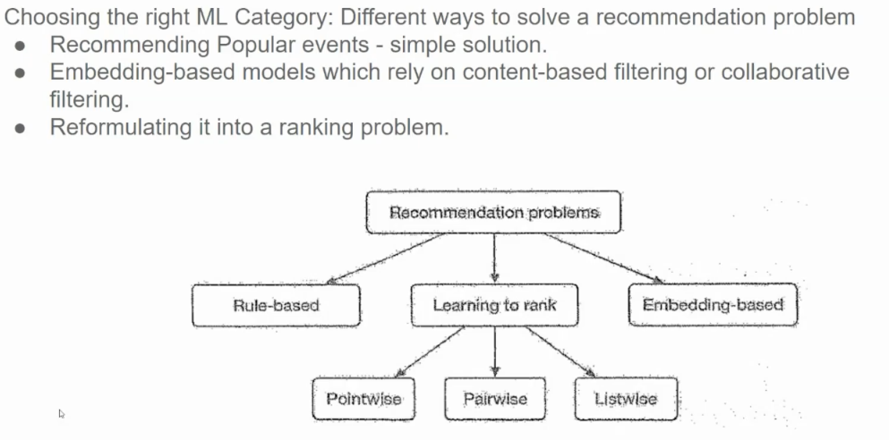

**Recommendation Problems**

1. Recommend most popular events in the area: not personalized, will be same for all users in the area.
2. **Rule-Based:** Relies on predefined rules to make recommendations. Simple to implement but often lacks personalization.
3. **Learning to Rank:** Can handle complex ranking scenarios and incorporate various features.
4. **Embedding-Based:** Similarity between embeddings is used to make recommendations. Can be based on content-based filtering (recommending similar items) or collaborative filtering (recommending items liked by similar users).

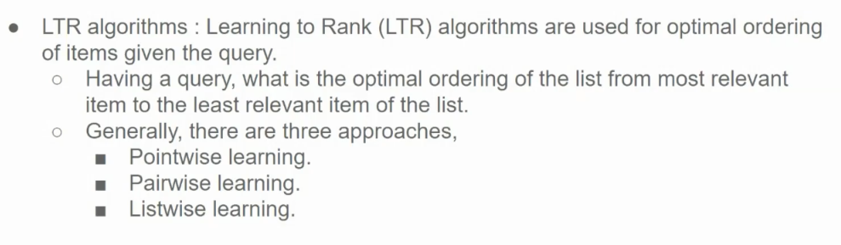

Learning to Rank (LTR) algorithms are machine learning models designed to automatically rank items, making them especially useful in search engines and recommendation systems. They learn the relevance of items based on training data and optimize the order of results to improve user satisfaction.

**Types of Learning to Rank Approaches**

1. **Pointwise**: Treats ranking as a classification problem by assigning a score or class to each item individually. Example: Logistic Regression or Support Vector Machines.
2. **Pairwise**: Considers pairs of items and learns their relative ranking by minimizing the number of incorrectly ordered pairs. Example: RankNet, LambdaRank.
3. **Listwise**: Directly optimizes the order of a list of items as a whole, typically with a loss function based on ranking metrics like NDCG. Example: LambdaMART, ListNet.

Each type has trade-offs in terms of computational complexity, accuracy, and applicability depending on the task.

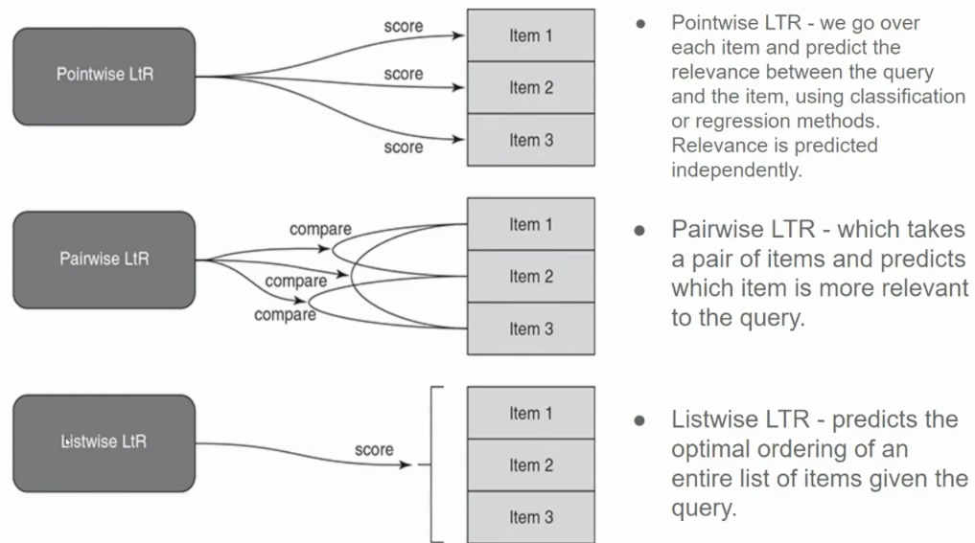

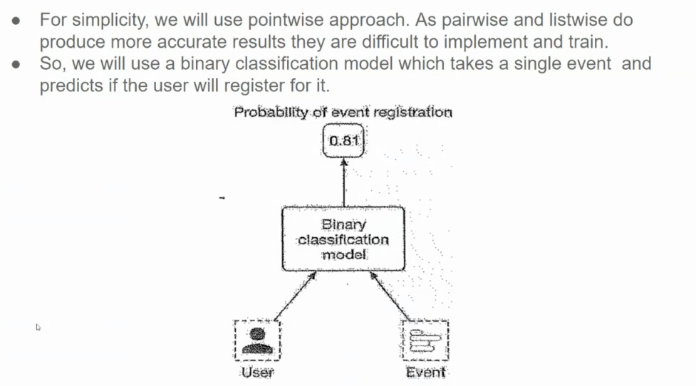

**Data**

* Features:
  + User features
    - age (bucketize -> one hot), gender, event history
  + Event features
    - price, No of registered users
    - date/ time (event date/ time, length, remained time to event)
    - location (city, country, accessibility)
    - description
    - host (& popularity)
  + User Event features
    - event price similarity
    - event description similarity
    - no. registered similarity
    - same city, state, country
    - distance
    - time similarity (event length, day, time of day)
  + Social features
    - No./ ratio of friends going
    - invited by friends (No)
    - hosted by friend (similarity)
  + context
    - location, time
* Feature preprocessing
  + one hot (gender)
  + bucketize + one hot (age, distance, time)
* feature processing
  + Batch (for static) vs Online (streaming, for dynamic) processing
  + efficient feature computation (e.g. for location, distance)
  + improve: embedding learning - for users and events

Some other features:

Event attendance-based metrics

1. Number of users who marked “attending” for our event
2. Number of users who marked “not attending” for our event
3. Number of users who marked “may be attending” for our event
4. Number of users who were invited to the event
5. Ratio of number of users not attending to the number of users attending
6. Ratio of number of users who might be attending to be number of users attending
7. Ratio of number of users invited to the number of users attending

Friends attendance-based metrics

1. Number of friends who marked “attending” for our event and normalized
2. Number of friends who marked “not attending” for our event and normalized
3. Number of friends who marked “may be attending” for our event and normalized
4. Number of friends who were invited to the event and normalized
5. Ratio of number of friends not attending to the number of friends attending
6. Ratio of number of friends who might be attending to the number of friends attending
7. Ratio of number of friends invited to the number of friends attending

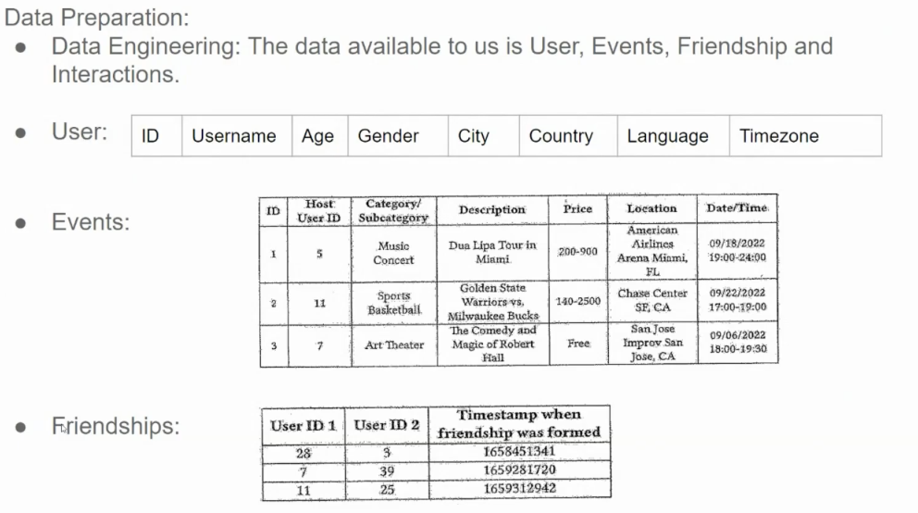

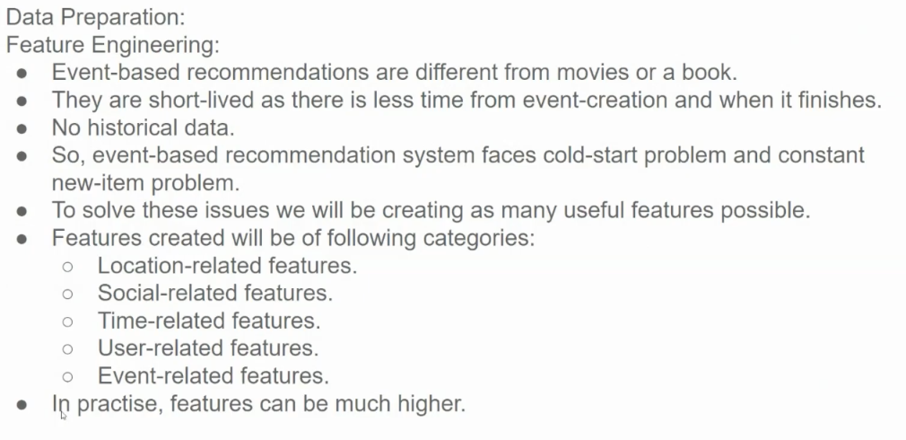

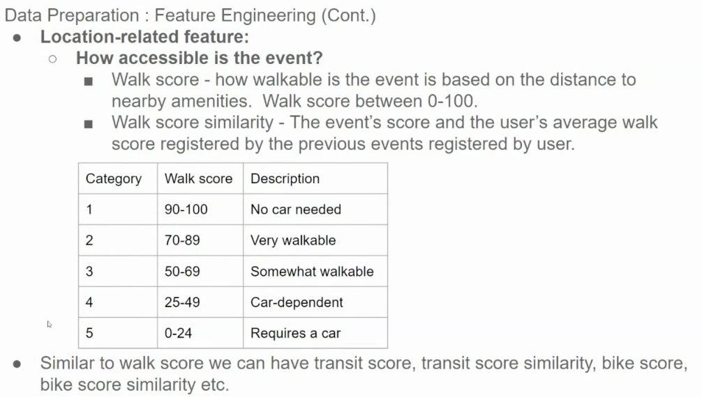

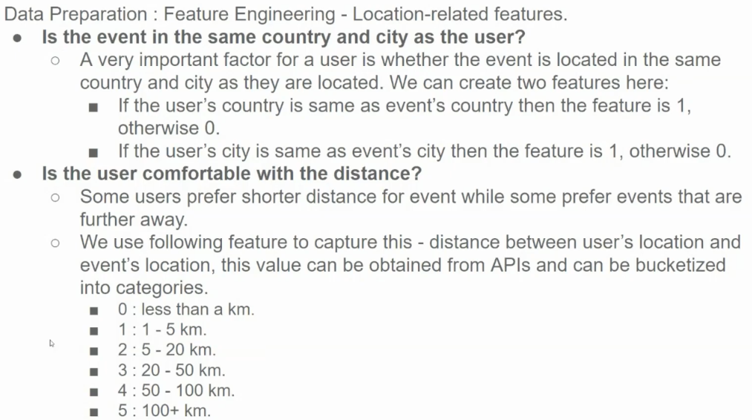

Self-Note: These features are crucial for personalized event recommendations:

* **Relevance:** Users are more likely to be interested in events that are geographically relevant to them.
* **User Preferences:** By considering distance preferences, the system can tailor recommendations to individual users.
* **Feasibility:** These features can help filter out events that are impractical for the user to attend based on distance and location.

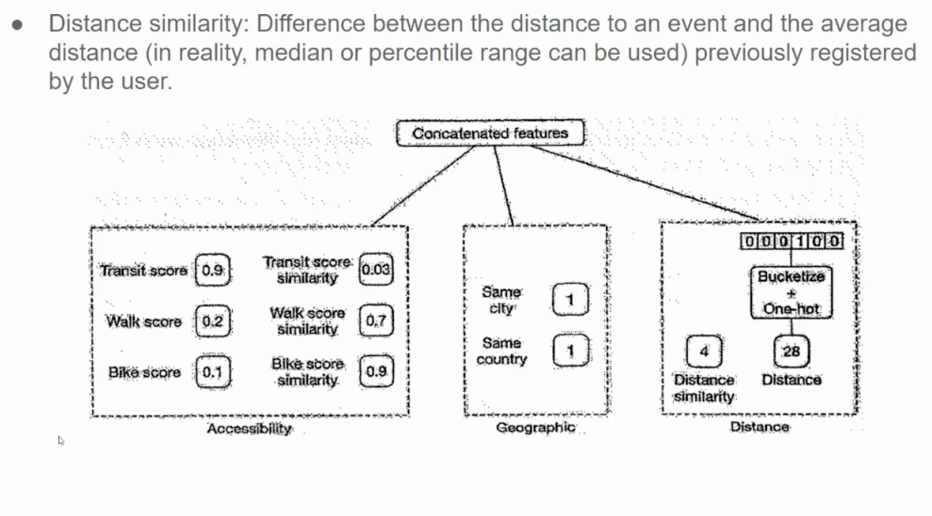

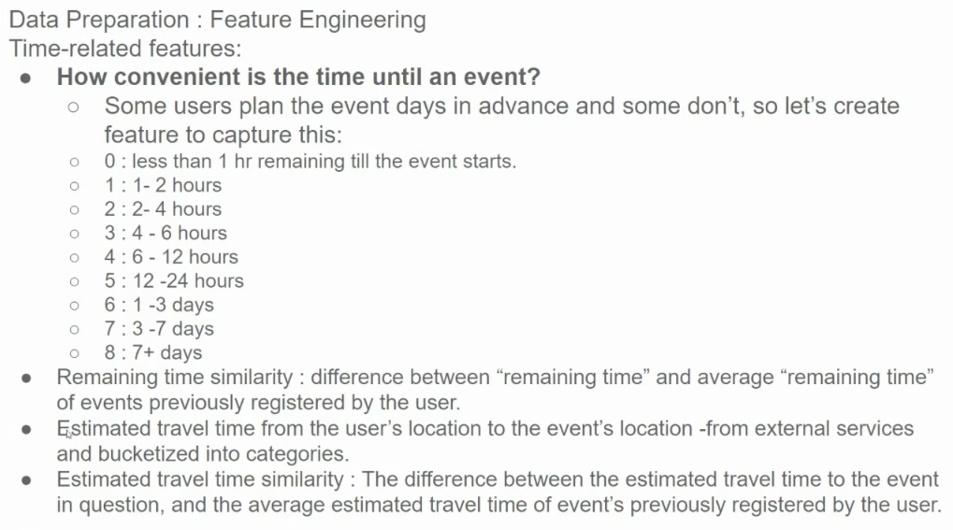

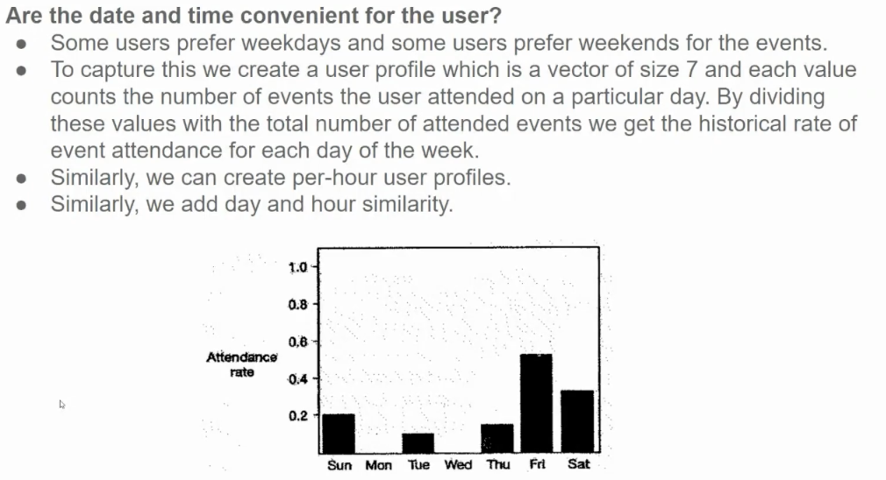

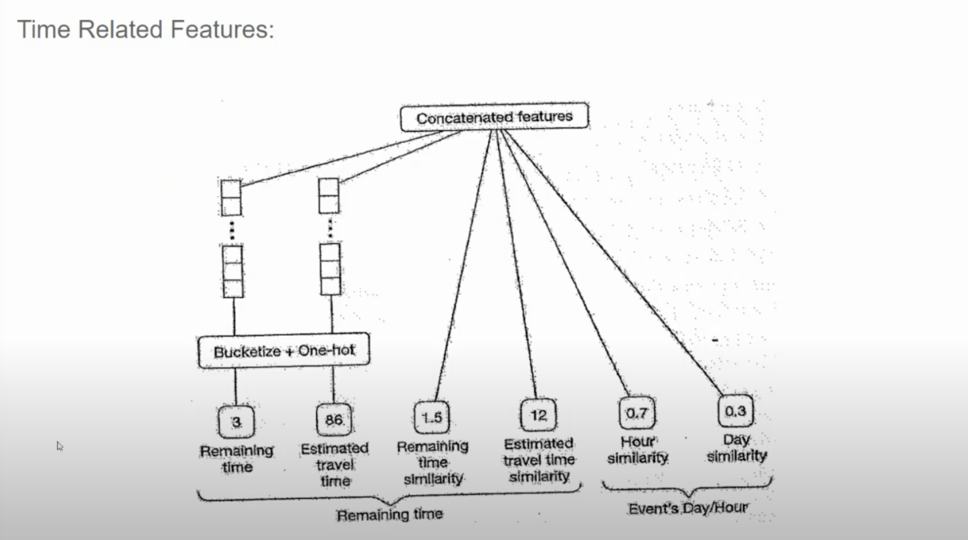

**Key Features and Their Engineering:**

1. **Remaining Time:**
   * **Bucketization:** The remaining time to the event can be categorized into buckets like "less than a day," "1-3 days," "3-7 days," and "more than 7 days."
   * **One-hot Encoding:** Each bucket can be represented as a binary feature.
2. **Estimated Travel Time:**
   * Similar to remaining time, estimated travel time can be bucketed into categories like "less than an hour," "1-2 hours," "2-4 hours," and so on.
   * **One-hot Encoding:** Each bucket can be represented as a binary feature.
3. **Time Similarity:**
   * This feature captures the similarity between the user's preferred event times and the event's scheduled time.
   * It can be calculated using techniques like cosine similarity or Euclidean distance between time vectors.
4. **Event's Day/Hour:**
   * This feature captures the specific day and hour of the event.
   * It can be represented as categorical features or numerical features (e.g., hour of the day).

**Self-Note: Why These Features Matter:**

* **Timeliness:** Users are more likely to be interested in events that are happening soon or within their preferred time frame.
* **Convenience:** Users may prefer events that are easier to attend, considering factors like travel time and event duration.
* **Personalization:** By understanding a user's time preferences, the system can tailor recommendations to their specific needs.

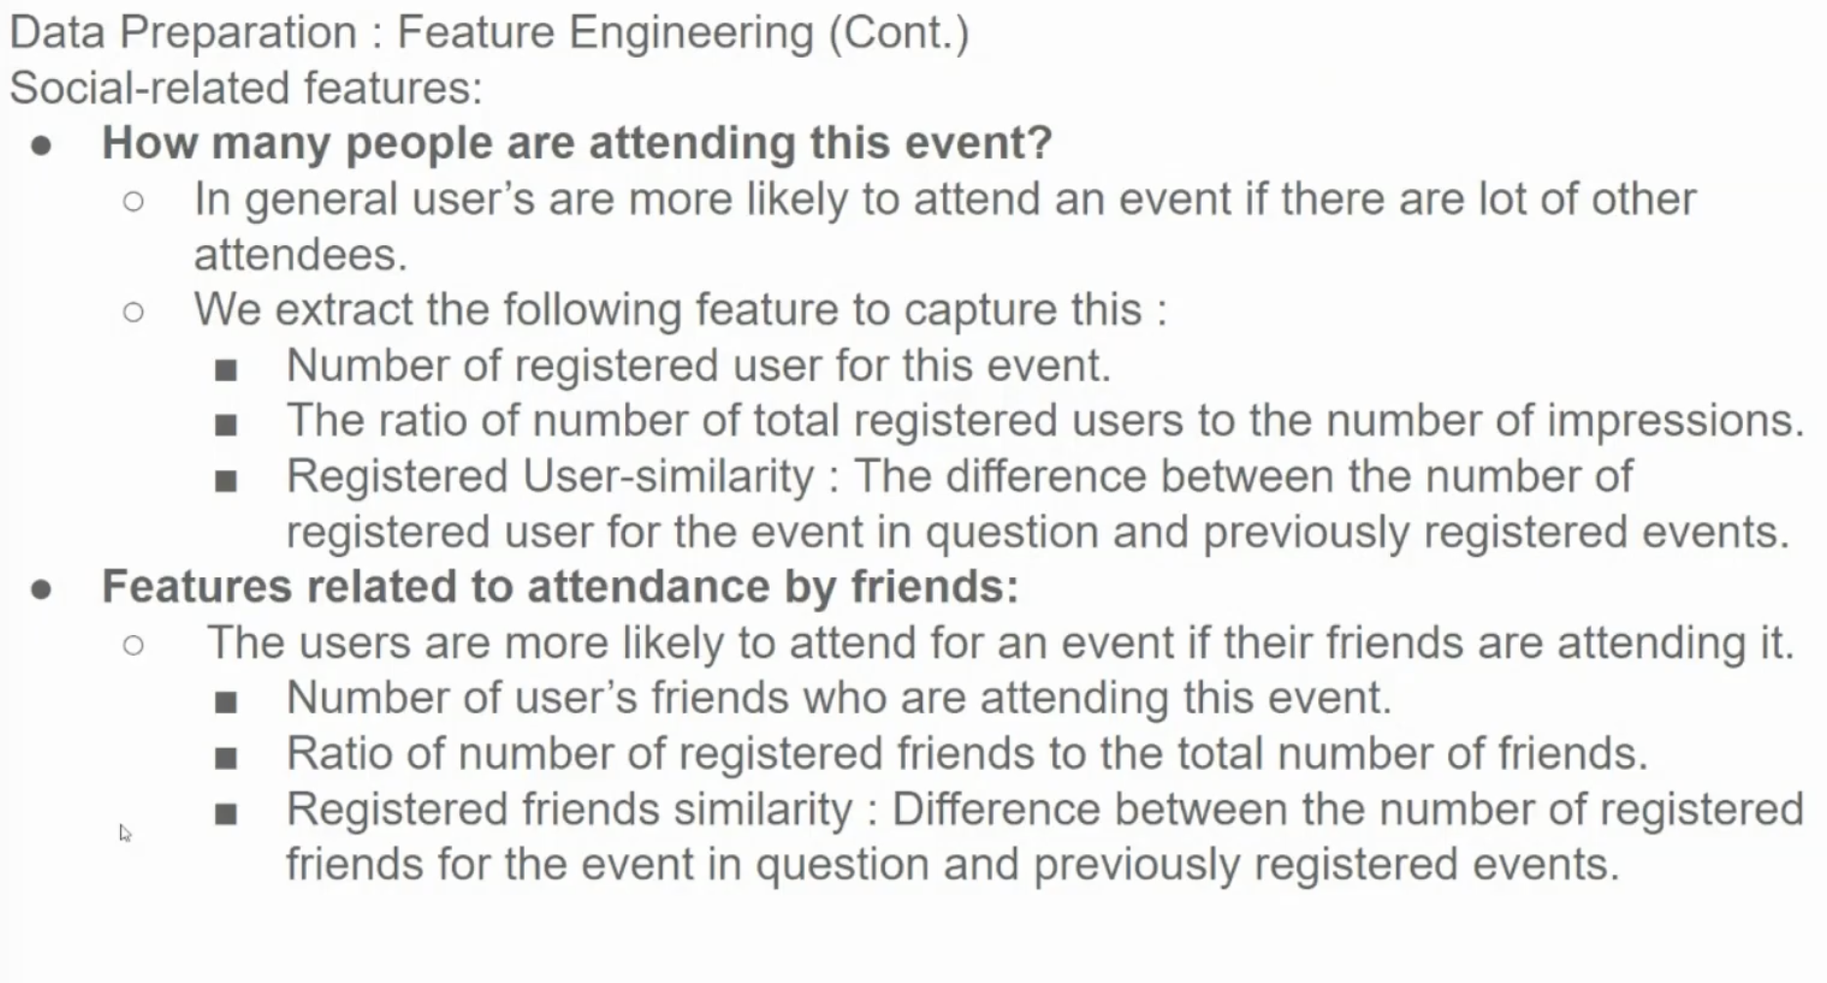

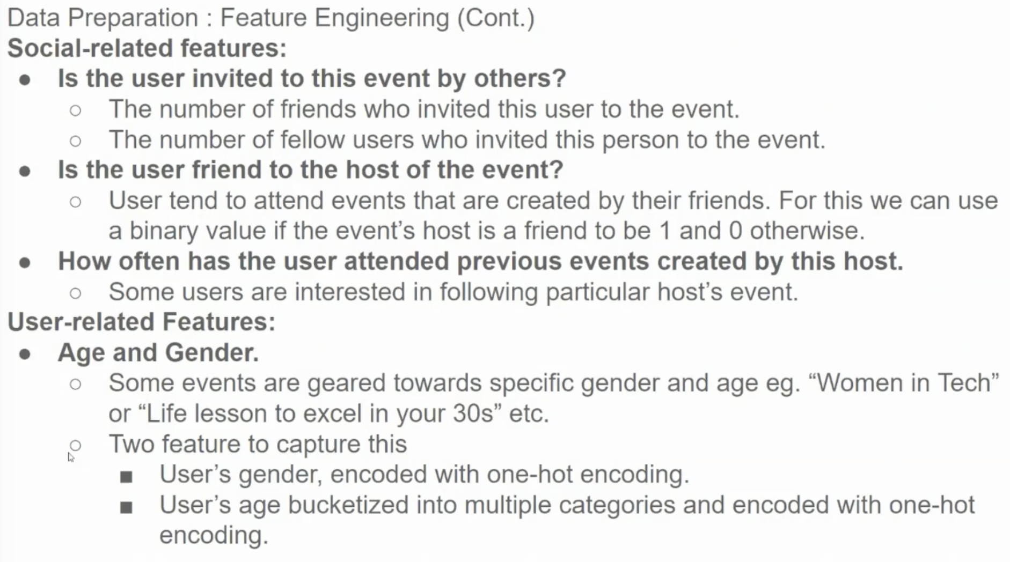

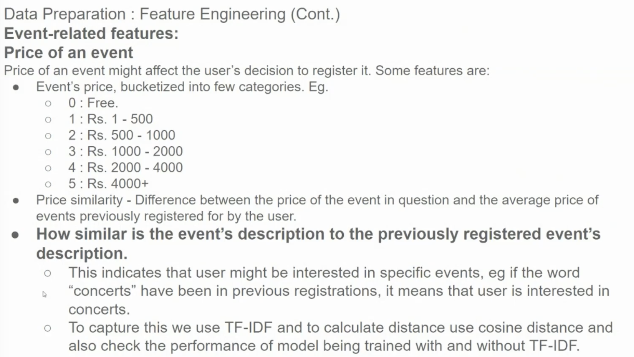

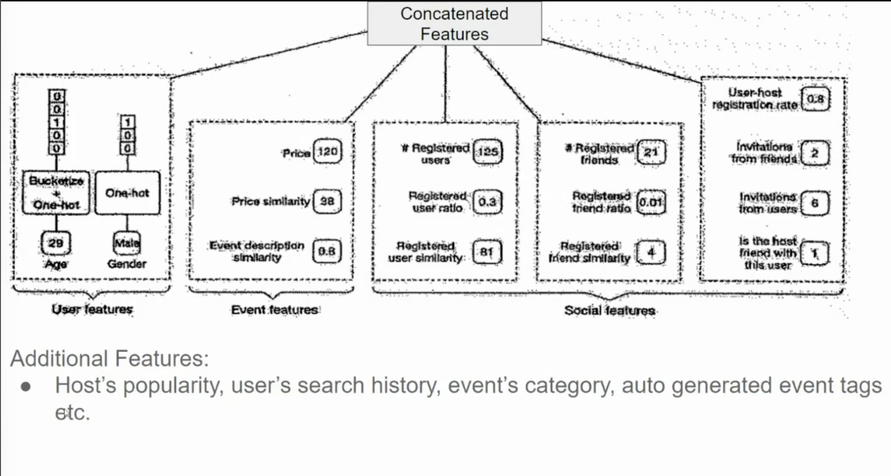

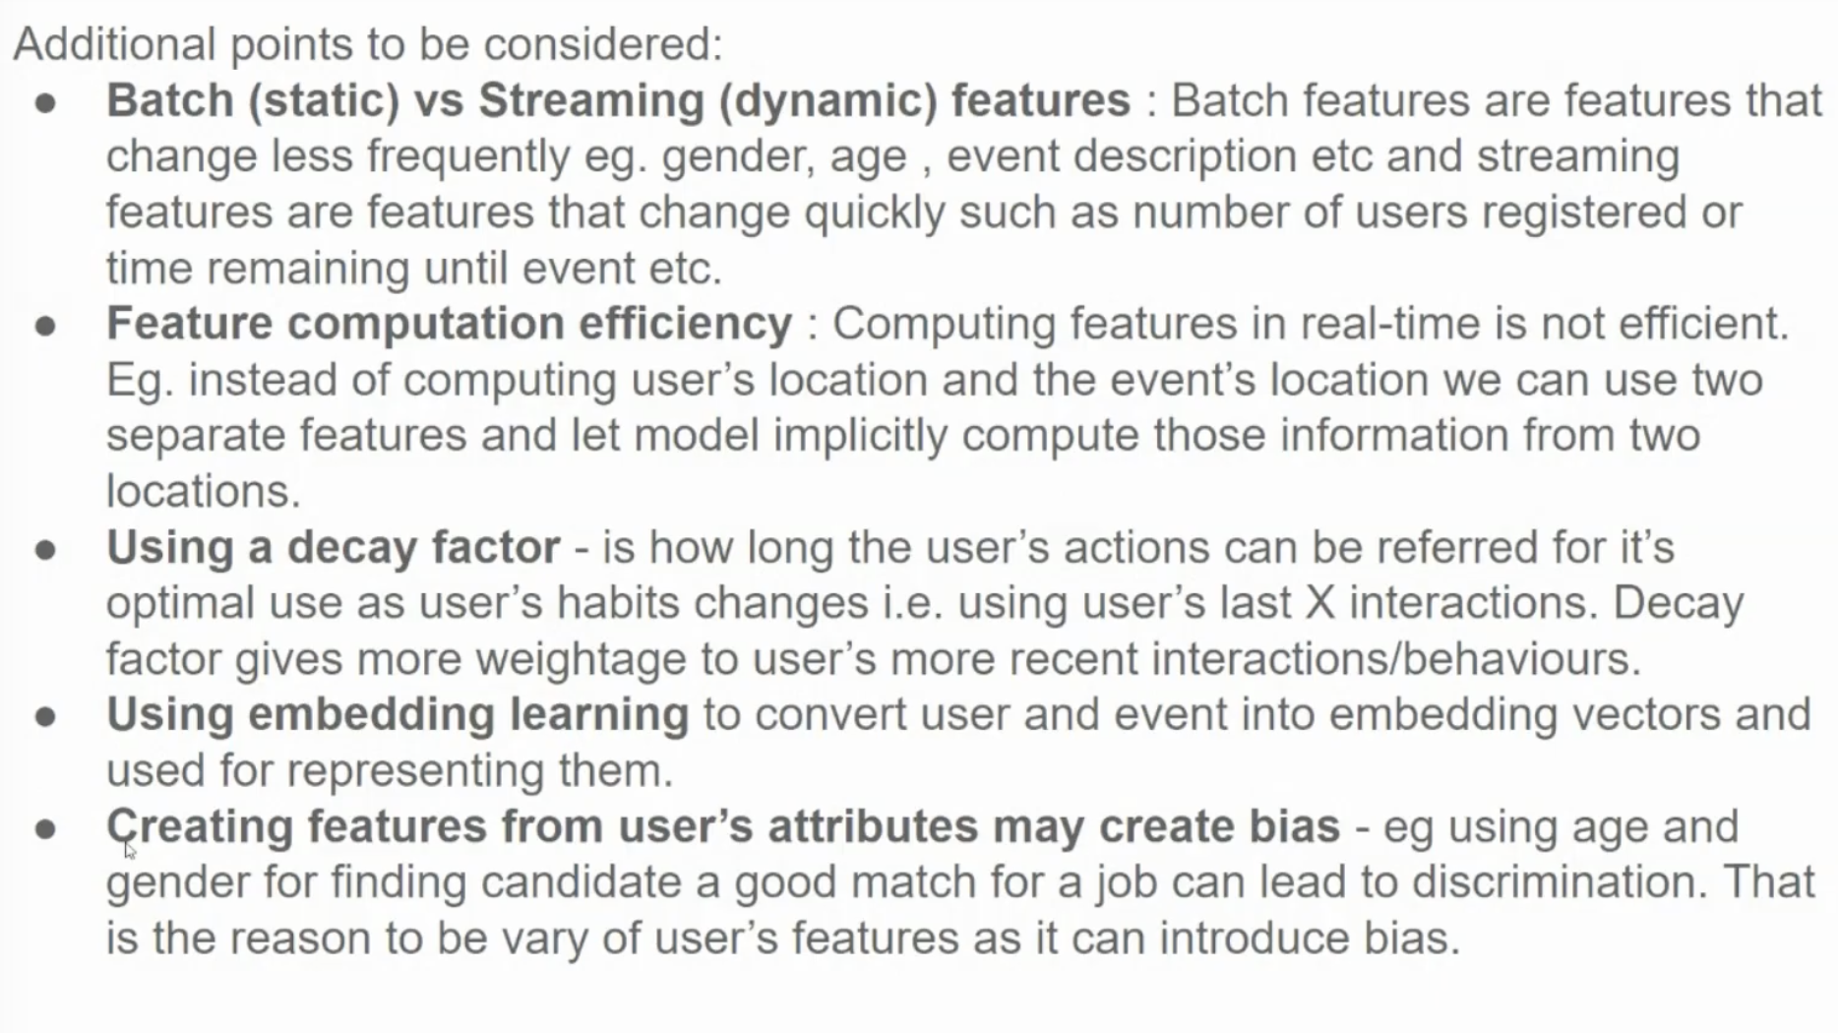

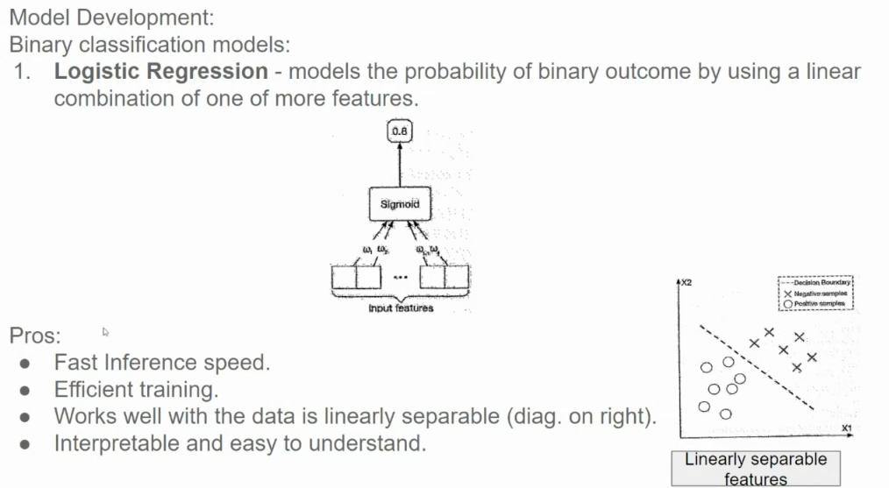

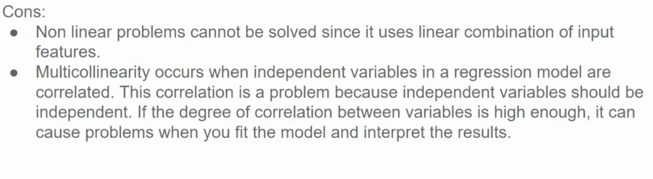

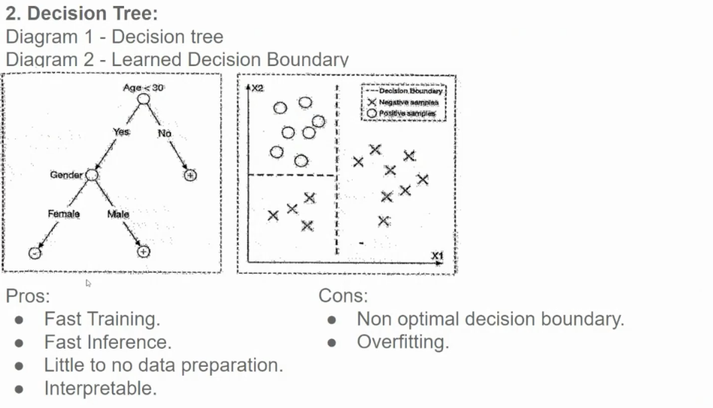

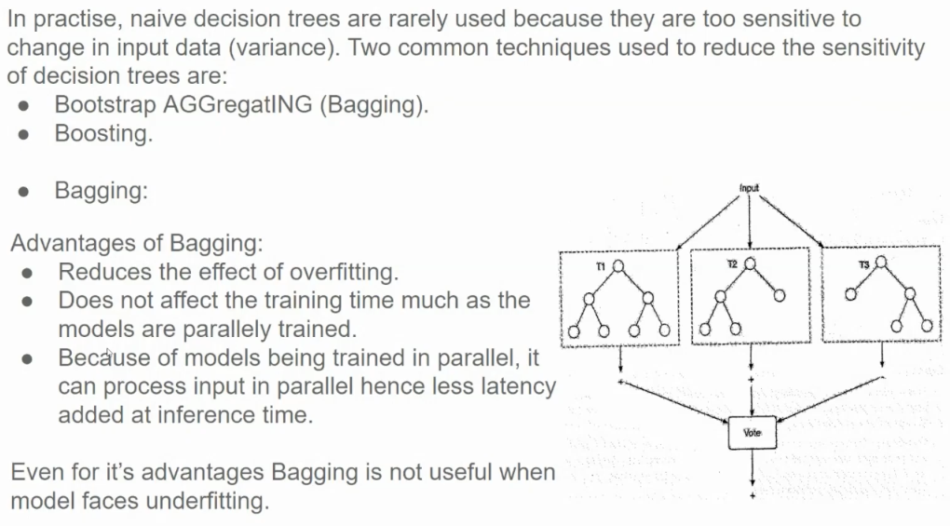

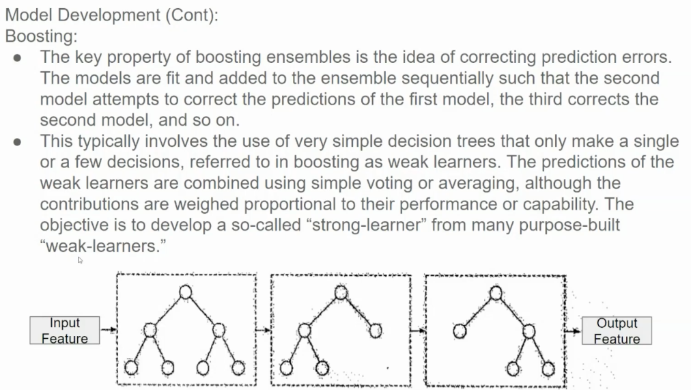

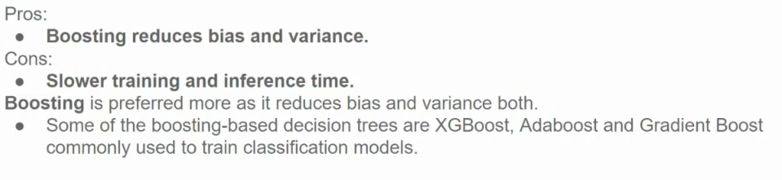

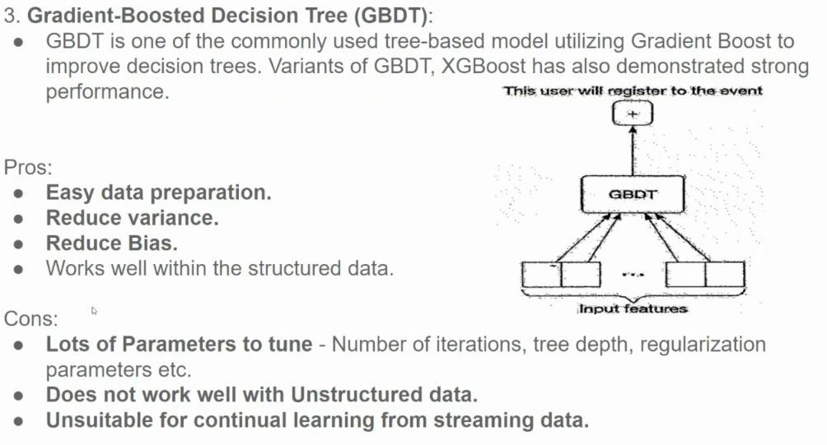

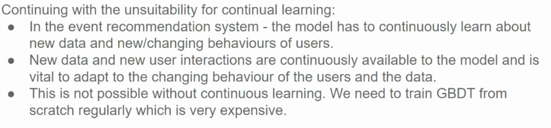

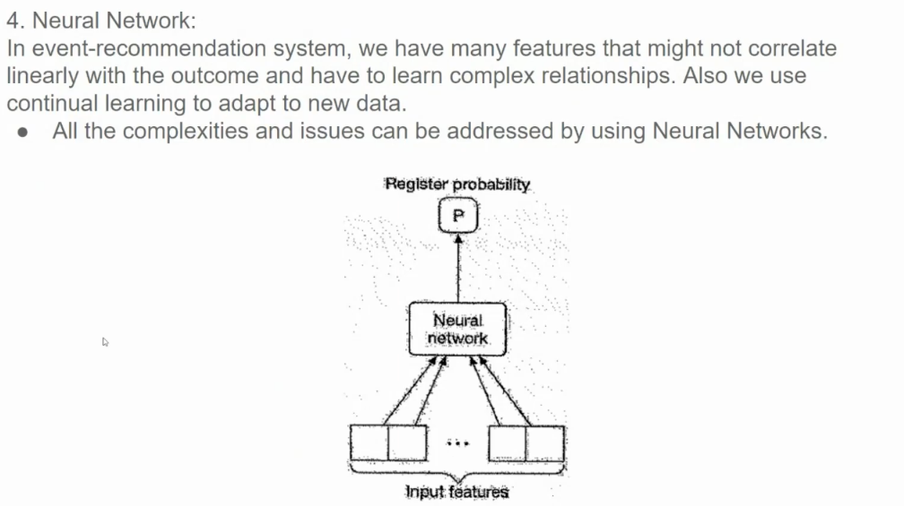

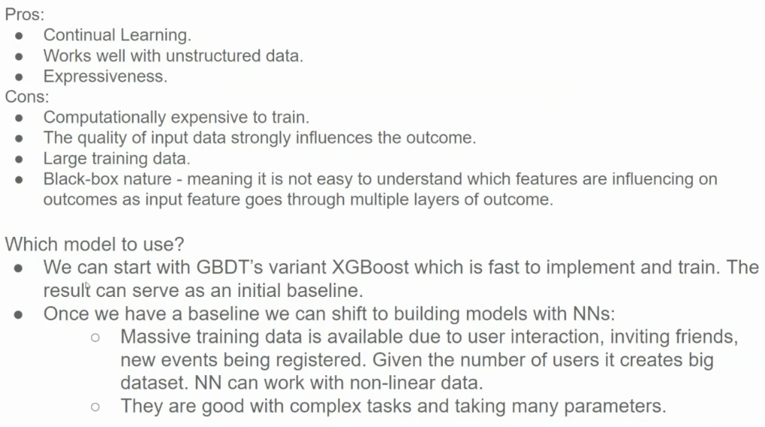

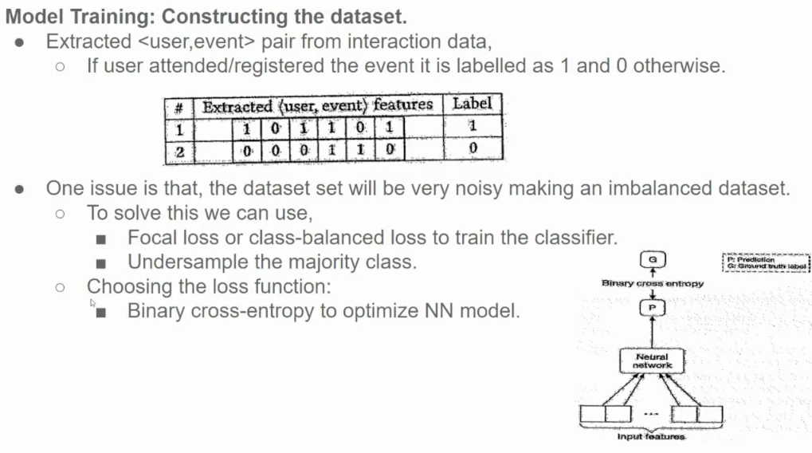

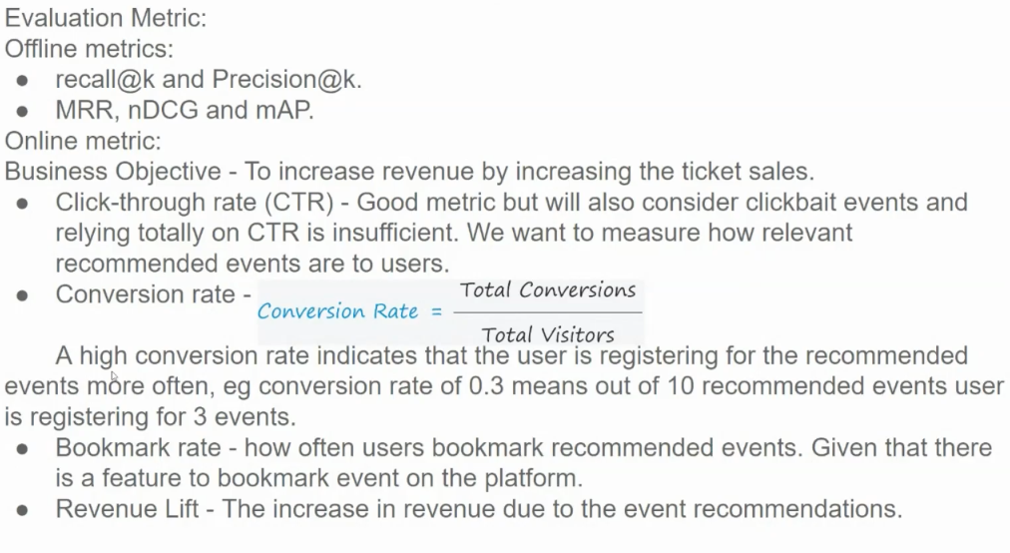

**Offline Metrics**

* **Recall@k:** Measures the proportion of relevant items that are recommended within the top k recommendations.
* **Precision@k:** Measures the proportion of recommended items that are actually relevant within the top k recommendations.
* **MRR (Mean Reciprocal Rank):** Measures the average reciprocal rank of the first relevant item in the ranked list. A higher MRR indicates better performance, as it rewards models that rank relevant items higher.
* **nDCG (Normalized Discounted Cumulative Gain):** Considers the position of relevant items in the ranked list. It assigns higher weights to items ranked higher and penalizes irrelevant items. A higher nDCG indicates better ranking quality.
* **MAP (Mean Average Precision):** Measures the average precision at different recall levels. It considers both precision and recall, making it a comprehensive metric.

**Online Metrics**

These metrics are used to evaluate the model's performance in a real-world setting.

* **Click-Through Rate (CTR):** Measures the proportion of users who click on a recommended event. While CTR is a useful metric, it's important to consider the quality of the clicks. A high CTR could be due to clickbait events rather than truly relevant recommendations.
* **Conversion Rate:** Measures the proportion of users who convert after clicking on a recommended event (e.g., purchasing a ticket). A higher conversion rate indicates that the system is effectively recommending events that users are interested in.
* **Bookmark Rate:** Measures the proportion of users who bookmark recommended events. This metric can be used to assess the long-term impact of recommendations, as bookmarked events may be considered for future purchases.
* **Revenue Lift:** Measures the increase in revenue generated by the recommendation system compared to a baseline (e.g., no recommendations). This is the ultimate metric for evaluating the business impact of the system.

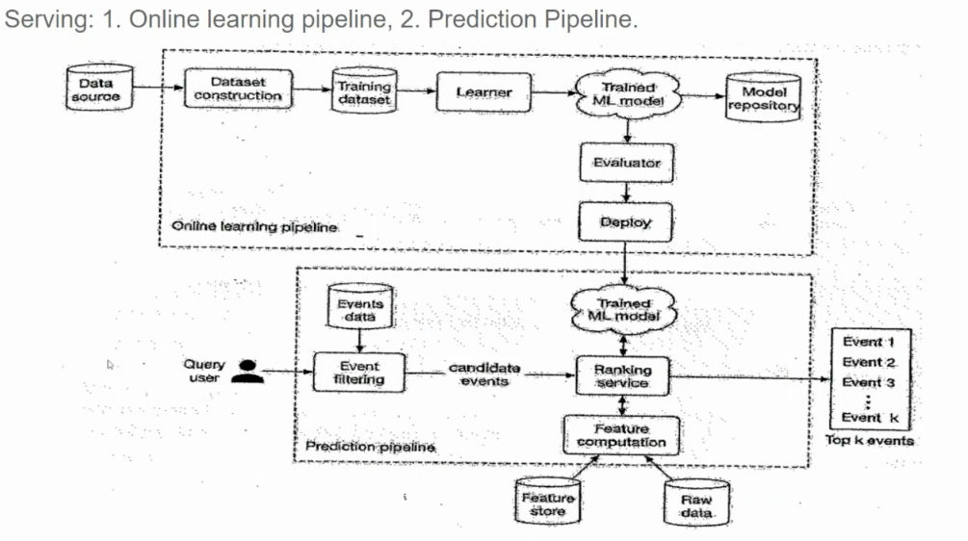

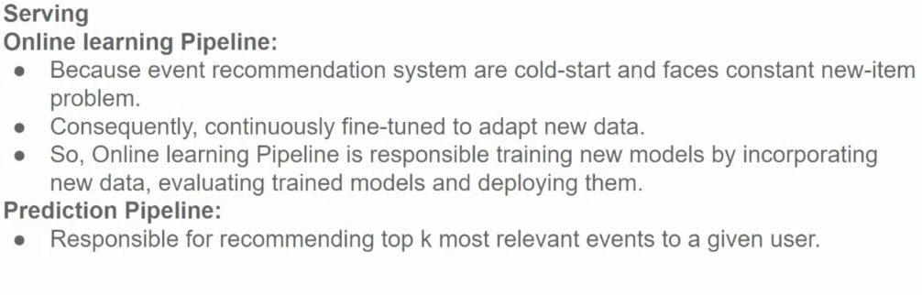

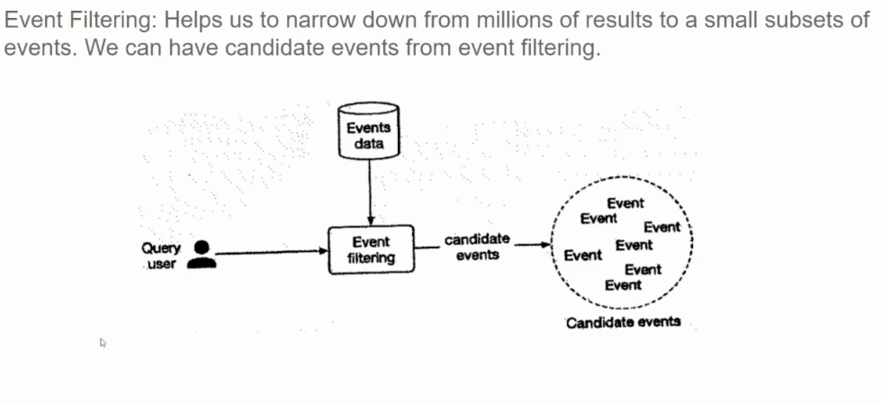

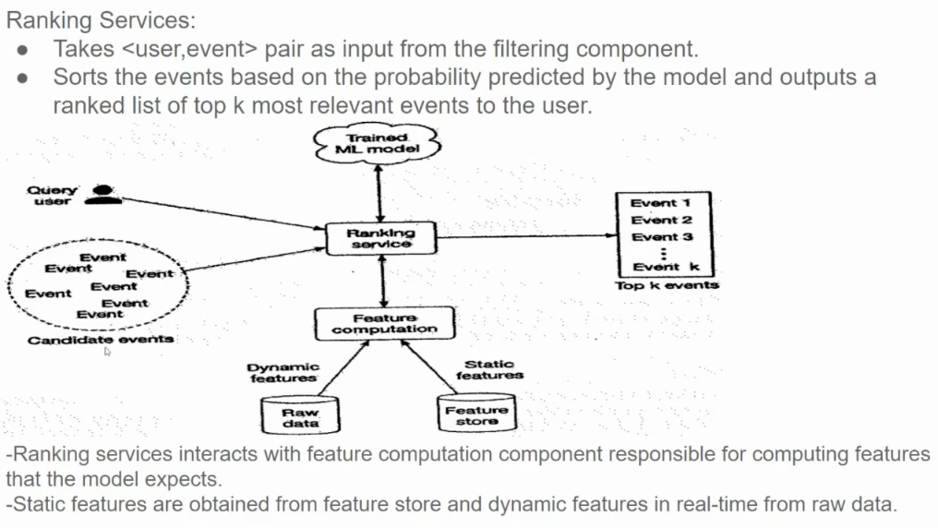

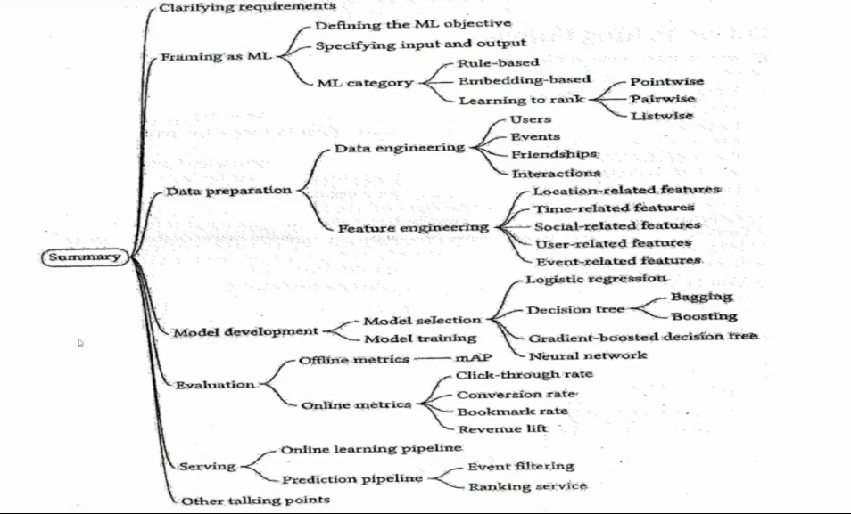

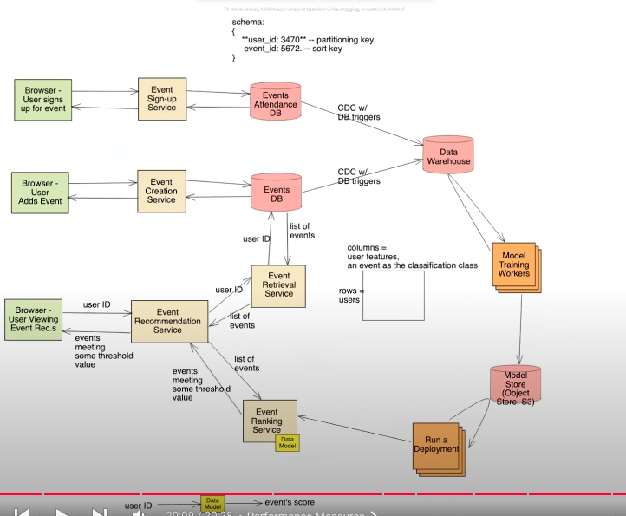

https://www.youtube.com/watch?v=1yLz6uvUJCQ&list=PLlvnxKilk3aKx0oFua-HTtFf-d_inQ8Qn&index=6